Sensor-Based IoT Simulation: Light-Activated LED
Task 2 — CodeAlpha IoT Internship

Project Overview
This project simulates a light-activated LED system using a Tinkercad circuit built around an Arduino UNO. A photoresistor (Light Dependent Resistor, LDR) continuously measures the surrounding light level, and the Arduino automatically switches an LED on when the light level drops below a defined threshold, and switches it off again once enough light is detected. This mimics the working principle of a real-world automatic streetlight or dark-sensing security light, where artificial lighting only activates when natural light is insufficient.

Components Used
  - Arduino UNO — the microcontroller running the control logic
  - Photoresistor (LDR) — analog sensor that detects ambient light intensity
  - LED — output device that turns on/off based on sensor readings
  - Resistors — current-limiting resistors for both the LDR voltage divider and the LED
  - Breadboard and jumper wires — used to connect all components to the Arduino

Circuit Connections
The photoresistor is wired as part of a voltage divider on the breadboard, with its output connected to the Arduino's analog pin A0. This allows the Arduino to read a variable voltage that changes with the amount of light falling on the sensor. The LED is connected through a current-limiting resistor to digital pin 7, which the Arduino drives HIGH or LOW to switch the LED on or off. Power and ground rails on the breadboard are connected to the Arduino's 5V and GND pins to supply the circuit.

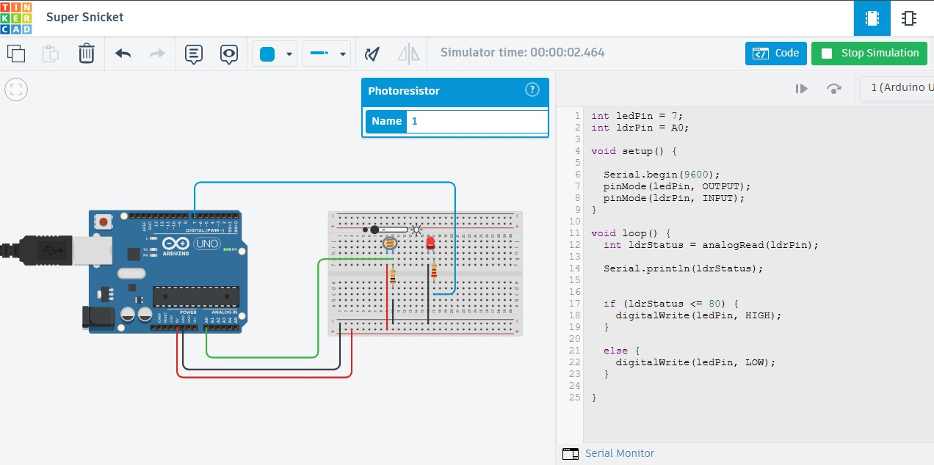
Figure 1: Circuit in bright-light condition — LDR reads above the threshold, LED remains OFF.
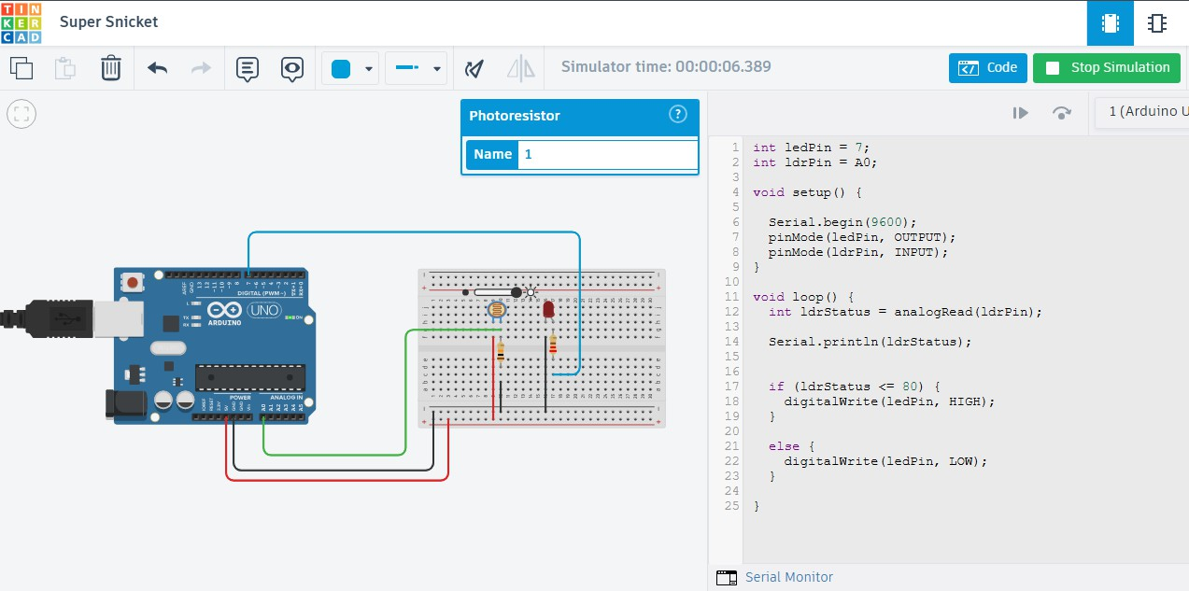
Figure 2: Circuit simulation running in Tinkercad with live sensor readings in the code/serial panel.

Arduino Code
int ledPin = 7; int ldrPin = A0;

void setup() { Serial.begin(9600); pinMode(ledPin, OUTPUT); pinMode(ldrPin, INPUT);
}

void loop() {
int ldrStatus = analogRead(ldrPin); Serial.println(ldrStatus);

if (ldrStatus <= 80) { digitalWrite(ledPin, HIGH);
}
else {
digitalWrite(ledPin, LOW);
}
}
- Code Explanation
The code begins by declaring two variables: ledPin, set to digital pin 7 where the LED is connected, and ldrPin, set to analog pin A0 where the photoresistor's signal is read. In the setup() function, serial communication is initialized at a baud rate of 9600 so sensor readings can be viewed in the Serial Monitor for testing purposes. The LED pin is configured as an OUTPUT since the Arduino needs to send voltage to it, while the LDR pin is configured as an INPUT since the Arduino is only reading a signal from it.
Inside the loop() function, analogRead(ldrPin) reads the current light level from the photoresistor as a value between 0 and 1023, which is stored in the variable ldrStatus. This value is printed to the Serial Monitor on every cycle using Serial.println(), allowing the actual sensor readings to be observed in real time as lighting conditions change in the simulation.
The core decision-making happens in the if-else block. If ldrStatus is less than or equal to 80, the condition is treated as a low-light reading, and digitalWrite(ledPin, HIGH) turns the LED on. If the reading is above 80, meaning there is enough ambient light, the else branch runs digitalWrite(ledPin, LOW), keeping the LED off. Because this check runs continuously inside loop(), the LED responds automatically and immediately to changes in light level, with no manual switching required.

Verification
The simulation was tested in Tinkercad by adjusting the light intensity on the photoresistor and observing the LED's behavior alongside the printed sensor values in the Serial Monitor. In bright conditions, the LDR reading stayed above 80 and the LED remained off, as seen in Figure 1. When the light level was reduced (simulating darkness), the LDR reading dropped to or below 80, and the LED turned on as expected, confirming that the code's logic correctly matches its intended behavior.

Conclusion
This simulation demonstrates a fundamental IoT concept: using a sensor to gather environmental data and a microcontroller to make automated decisions based on that data, without any human intervention. Although simple, this same sensing-and-response pattern is the foundation of more advanced IoT systems used in smart homes, smart streetlights, and energy-saving automation, where devices respond intelligently to real-world conditions.

